# Verifying That Two Functions Are Inverse Functions

For any one-to-one function $f\left(x\right)=y$, a function $f^{-1}(x)$ is an **inverse function** of $f$ if $f^{-1}\left(y\right)=x$. This can also be written as $f^{-1}\left(f\left(x\right)\right)=x$ for all $x$ in the domain of $f$. It also follows that $f\left(f^{-1}\left(x\right)\right)=x$ for all $x$ in the domain of $f^{-1}$ if $f^{-1}$ is the inverse of $f$.

Given a function $f(x)$, the notation for its inverse, $f^{-1}(x)$, is read as “ $f$ inverse of $x$.”

Inverse functions “undo” each other. In other words, if we compose *f* and $f^{-1}$, we should get back out $x$.

$f^{-1}(f(x))=_________$ and ${f(f}^{-1}(x))=_________$

Given two functions $f(x)$ and $g(x)$, we can test whether they are inverses of each other by

1. Determine whether or .

2. If BOTH statements are true then they are inverses of each other ( $g=f^{-1}$ and $f=g^{-1}$).

If EITHER statement is false, then they are not inverses of each other.

Examples

1. Let $f(x)=2x+6$ and $g(x)=\frac{1}{2}x-3$. Verify that the functions are inverses.
2. If $f\left(x\right)=\frac{1}{x+2}$ and $g\left(x\right)=\frac{1}{x}-2$, is $g=f^{-1}?$

# Finding the Domain and Range of Inverse Functions

The inverse function of *f* receives $y$ as an input and outputs $x$. In other words, we switch the domain and the range.

The **range** of a function $f(x)$ is the domain of the inverse function $f^{-1}(x)$.

The **domain** of $f(x)$ is the range of $f^{-1}(x)$.

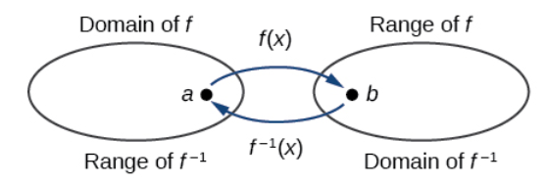

# Finding and Evaluating Inverse Functions

Once we have a one-to-one function, we can evaluate its inverse at specific inputs or construct a complete representation of the inverse function in many cases.

Examples

| $t$ (minutes) | 30 | 50 | 70 | 90 |
| --- | --- | --- | --- | --- |
| $f\left(t\right)$ (miles) | 20 | 40 | 60 | 70 |

1. Using the table below, find and interpret $f(70)$ and $f^{-1}\left(70\right)$.
2. A function $g(x)$ is given below. Find $g(3)$ and $g^{-1}(3)$.

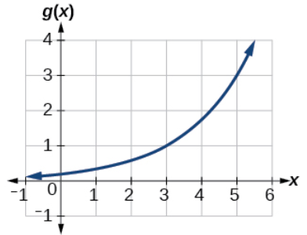

# Finding Inverses of Functions Represented by Formulas

Recall: The inverse function of *f* receives $y$ as an input and outputs $x$. In other words, we switch the domain and the range.

To find the inverse of a function:

Make sure $f$ is a one-to-one function.

Solve for $x$.

Interchange $x$ and $y$.

Replace $y$ with $f^{-1}(x)$.

Examples: For each of the following, find the inverse of the function given.

$g\left(x\right)=\frac{1}{3}(x-5)$

$h\left(x\right)=2+\sqrt{x-4}$

$f\left(x\right)=\frac{5x}{x-3}$

# Finding Inverse Functions and Their Graphs

Since the domain and range of the inverse function are simply the range and domain of the original function, to graph the inverse function reverse the $x$-and $y$-values of the original function’s graph. This will produce a graph of the inverse function.

If a function passes the horizontal line test (one-to-one function), then it has an inverse. We can also think of this as reflecting the graph of the original function over the line $y=x$.

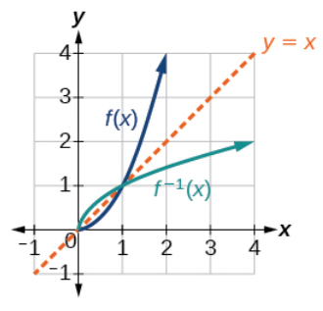

Example

Given the graph of $f(x)$ below, sketch a graph of $f^{-1}(x)$.

